**PROJECT TITLE-SMART WATER FOUNTAIN- INTERNET OFTHINGS**

TEAM MEMBERS:

**MENTOR:**

**Ms. R Keerthana**

THIRUKUMARAN M

VIGNESH B

RAMPRASATH G

NITHISHKUMAR S

VASANTH S

**PHASE 4: DEVELOPMENT PART 2**

**PROBLEM DEFINITION:**

In this phase of the project, we will define the problem statement and outline a design thinking approach for the implementation of the Smart Public Fountain project. The project aims to provide real-time data on fountain availability and cleanliness to the public through a web-based platform or mobile app. This document will help us understand the project's objectives and how to proceed with its implementation.

**PROBLEM STATEMENT:**

"The current water fountains in public spaces often suffer from issues such as contamination, inefficient water usage, and the lack of user-friendly features. There is a need for a smart water fountain solution that addresses these challenges by providing clean, safe, and easily accessible drinking water while also promoting sustainability and convenience through advanced technology and monitoring."

1. Water Conservation:

Many traditional water fountains waste a significant amount of water due to continuous flow, even when not in use. The problem is to design a smart water fountain that conserves water effectively. The fountain should only dispense water when someone is present and needs a drink. It should also prevent water wastage due to spillage or overuse.

1. User Convenience and Hygiene:

Traditional water fountains often lack proper hygiene measures, such as sensors to dispense water without physical contact, leading to concerns about water quality. The problem is to create a smart water fountain that prioritizes user convenience and hygiene. This includes touchless operation, water filtration, and a user-friendly interface for easy access.

DEVELOPMENT PART:

Design mobile apps for iOS and Android platforms that provide users with access to realtime fountain information

**Screenshots of the mobile App implementation part:**

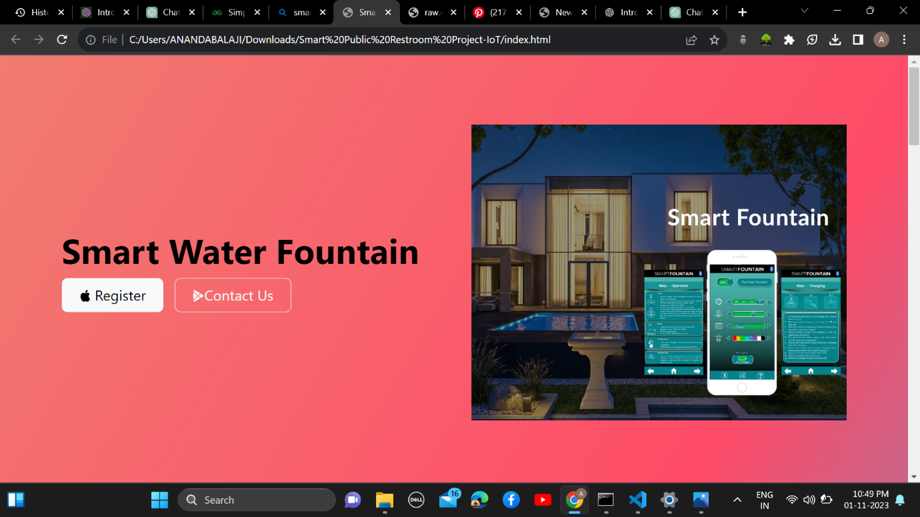

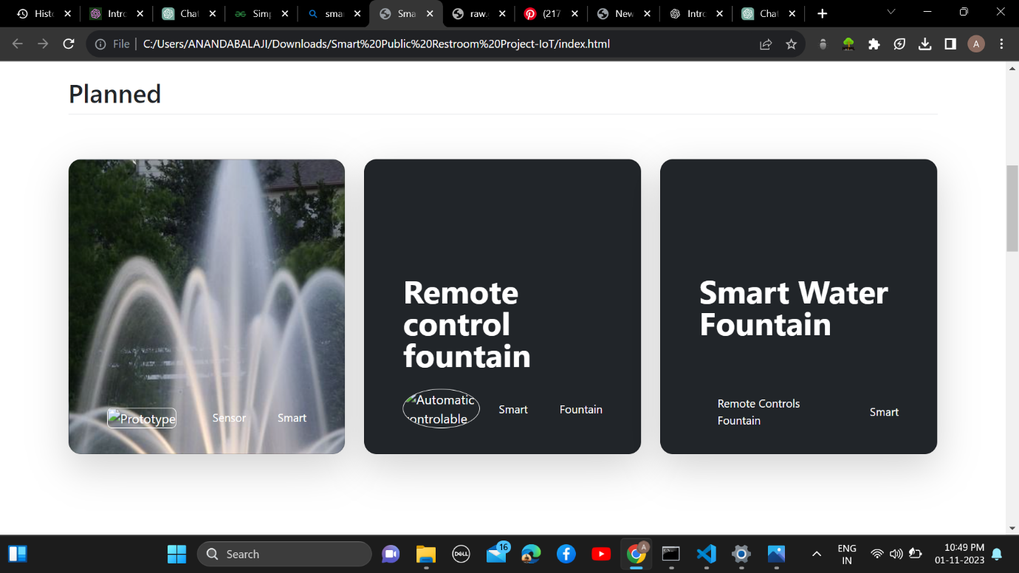

**Features:**

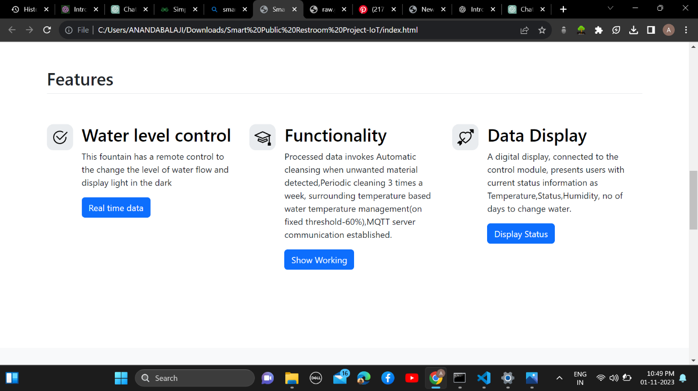

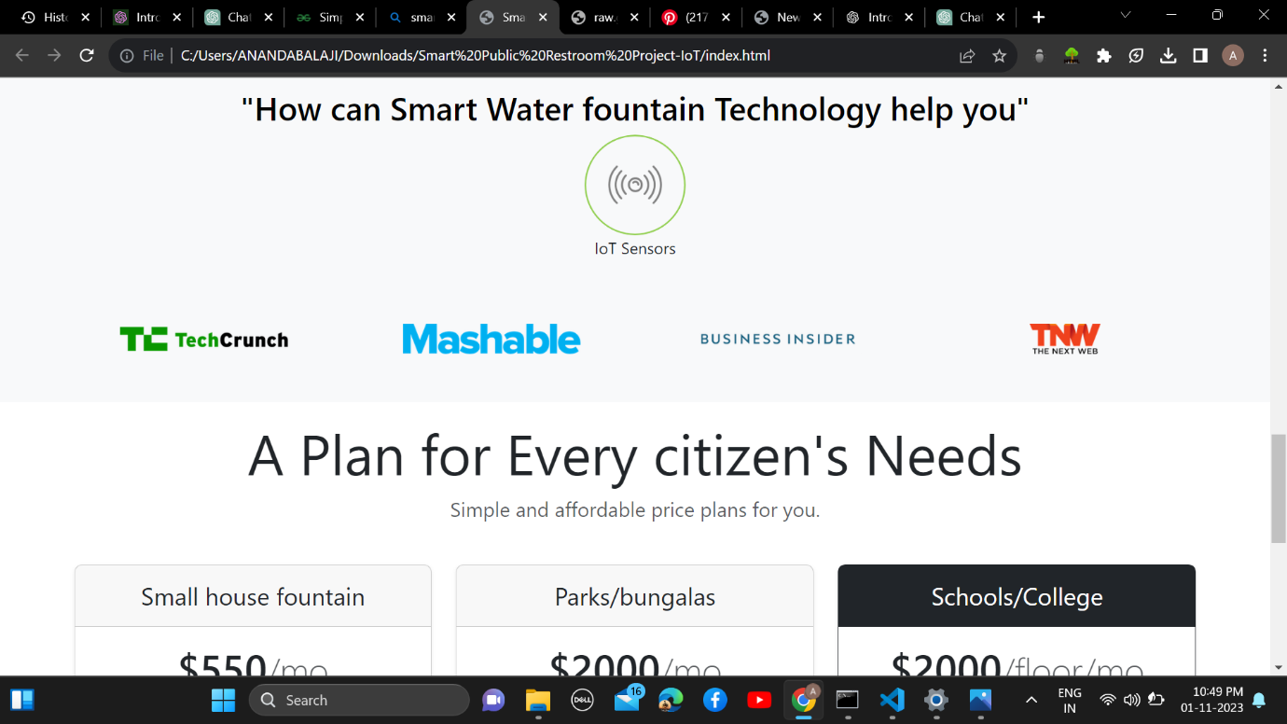

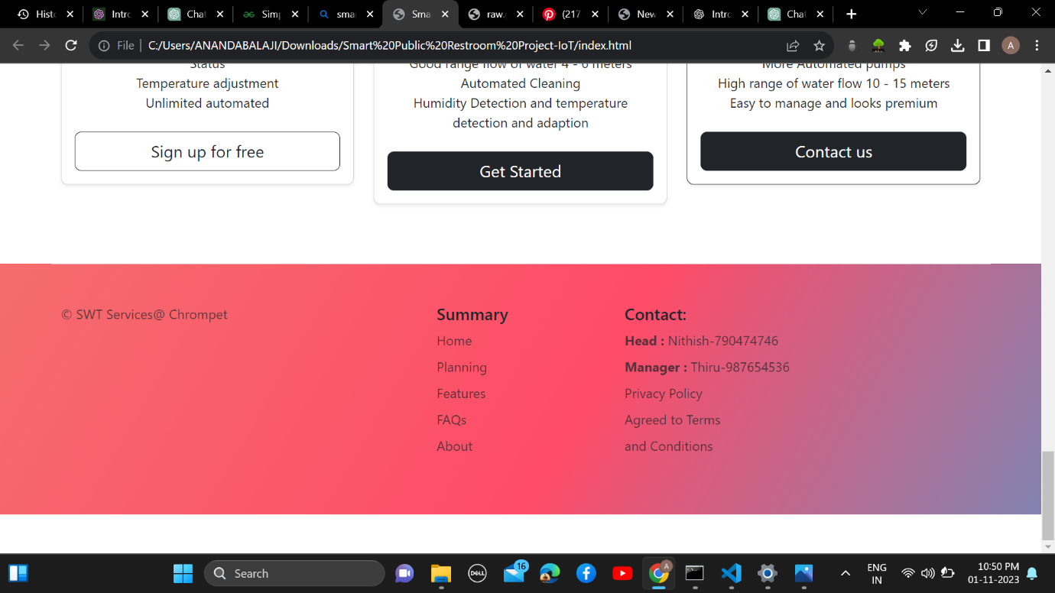

**Advancements:**

